Central Tendency – Percentile Analysis Report
Output Result:

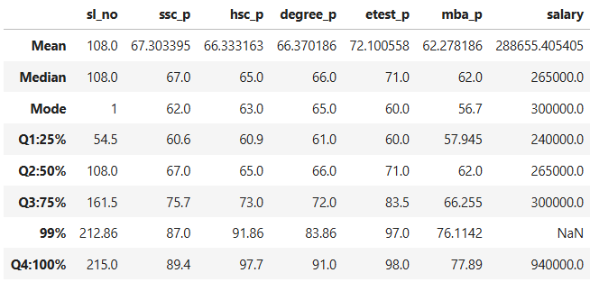

Summary of Percentile Analysis

SSLC
- The student’s mark increased by 6.4% from Q1 (25%) to Q2 (50%).
- The student’s mark increased by 8.7% from Q2 (50%) to Q3 (75%).
- The student’s mark increased by 11.3% from Q3 (75%) to 99th percentile.
- The student’s mark increased by 2.4% from 99th percentile to Q4 (100%).
HSC
- The student’s mark increased by 4.1% from Q1 (25%) to Q2 (50%).
- The student’s mark increased by 8% from Q2 (50%) to Q3 (75%).
- The student’s mark increased by 18.86% from Q3 (75%) to 99th percentile.
- The student’s mark increased by 5.84% from 99th percentile to Q4 (100%).
Degree
- The student’s mark increased by 5% from Q1 (25%) to Q2 (50%).
- The student’s mark increased by 6% from Q2 (50%) to Q3 (75%).
- The student’s mark increased by 11.86% from Q3 (75%) to 99th percentile.
- The student’s mark increased by 7.14% from 99th percentile to Q4 (100%).

Entrance Test
- The student’s mark increased by 11% from Q1 (25%) to Q2 (50%).
- The student’s mark increased by 12.5% from Q2 (50%) to Q3 (75%).
- The student’s mark increased by 13.5% from Q3 (75%) to 99th percentile.
- The student’s mark increased by 1% from 99th percentile to Q4 (100%).
MBA
- The student’s mark increased by 4.05% from Q1 (25%) to Q2 (50%).
- The student’s mark increased by 4.26% from Q2 (50%) to Q3 (75%).
- The student’s mark increased by 9.85% from Q3 (75%) to 99th percentile.
- The student’s mark increased by 1.78% from 99th percentile to Q4 (100%).

